Supplementary Table 1. Details of the 48 independent SNPs used as instrumental variables (IVs) in the two-sample Mendelian randomization analysis.
SNP | chr | pos | EA | OA | exposure | beta.  exposure | se.  exposure | eaf.  exposure | pval.  exposure | samplesize.  exposure | outcome | beta.  outcome | se.  outcome | eaf.  outcome | pval.  outcome | samplesize.  outcome | F
rs10491244 | 5 | 82420208 | A | G | ALP | 0.03 | 0.004 | 0.28 | 4.40E-09 | 118886 | VTE | -0.09 | 0.052 | 0.23 | 0.0981 | 18931 | 31
rs10892246 | 11 | 118610716 | G | A | ALP | 0.05 | 0.005 | 0.83 | 6.10E-19 | 118886 | VTE | 0.07 | 0.049 | 0.72 | 0.1476 | 18931 | 73
rs10893506 | 11 | 126406065 | C | T | ALP | 0.06 | 0.004 | 0.65 | 1.30E-50 | 118886 | VTE | -0.03 | 0.047 | 0.69 | 0.4828 | 18931 | 201
rs10995443 | 10 | 63110213 | C | T | ALP | 0.03 | 0.004 | 0.36 | 3.00E-14 | 118886 | VTE | 0.05 | 0.049 | 0.25 | 0.287 | 18931 | 52
rs111311275 | 19 | 48700476 | G | A | ALP | 0.08 | 0.006 | 0.18 | 2.40E-42 | 118886 | VTE | -0.16 | 0.067 | 0.13 | 0.0169 | 18931 | 222
rs11665674 | 19 | 48693018 | G | A | ALP | -0.12 | 0.004 | 0.48 | 3.40E-167 | 118886 | VTE | 0.08 | 0.043 | 0.46 | 0.0738 | 18931 | 861
rs1256327 | 1 | 21571283 | G | A | ALP | -0.03 | 0.005 | 0.22 | 1.30E-12 | 118886 | VTE | 0.00 | 0.047 | 0.29 | 0.9381 | 18931 | 45
rs1257221 | 2 | 134259047 | C | A | ALP | -0.03 | 0.005 | 0.75 | 8.10E-13 | 118886 | VTE | 0.06 | 0.048 | 0.72 | 0.1753 | 18931 | 47
rs12825673 | 12 | 460779 | A | G | ALP | 0.05 | 0.004 | 0.31 | 3.90E-36 | 118886 | VTE | -0.03 | 0.045 | 0.36 | 0.5277 | 18931 | 143
rs167537 | 17 | 7137687 | T | C | ALP | 0.03 | 0.005 | 0.22 | 3.10E-08 | 118886 | VTE | 0.01 | 0.050 | 0.22 | 0.8912 | 18931 | 29
rs1697406 | 1 | 21577774 | G | A | ALP | -0.13 | 0.005 | 0.82 | 2.50E-148 | 118886 | VTE | -0.03 | 0.053 | 0.78 | 0.5734 | 18931 | 607
rs1697421 | 1 | 21496799 | T | C | ALP | -0.09 | 0.004 | 0.41 | 1.00E-113 | 118886 | VTE | 0.01 | 0.043 | 0.52 | 0.7666 | 18931 | 465
rs2233156 | 19 | 40775795 | T | C | ALP | 0.03 | 0.005 | 0.18 | 2.60E-08 | 118886 | VTE | 0.00 | 0.054 | 0.20 | 0.9919 | 18931 | 28
rs2642438 | 1 | 220796686 | G | A | ALP | 0.03 | 0.005 | 0.82 | 5.50E-09 | 118886 | VTE | -0.03 | 0.059 | 0.83 | 0.5872 | 18931 | 30
rs2792736 | 10 | 112161401 | A | T | ALP | -0.03 | 0.005 | 0.78 | 1.80E-11 | 118886 | VTE | -0.02 | 0.046 | 0.64 | 0.7373 | 18931 | 40
rs2793443 | 6 | 24462939 | C | T | ALP | 0.06 | 0.005 | 0.18 | 4.80E-30 | 118886 | VTE | 0.03 | 0.062 | 0.14 | 0.6282 | 18931 | 116
rs2954021 | 8 | 125469835 | G | A | ALP | -0.04 | 0.004 | 0.55 | 5.40E-20 | 118886 | VTE | 0.05 | 0.043 | 0.58 | 0.2687 | 18931 | 74
rs3735840 | 8 | 144427623 | A | G | ALP | -0.02 | 0.004 | 0.40 | 1.20E-08 | 118886 | VTE | 0.03 | 0.043 | 0.41 | 0.4643 | 18931 | 29
rs377513446 | 11 | 288845 | C | A | ALP | -0.05 | 0.005 | 0.18 | 4.10E-25 | 118886 | VTE | 0.01 | 0.082 | 0.07 | 0.9372 | 18931 | 100
rs3817640 | 11 | 297970 | T | C | ALP | 0.07 | 0.004 | 0.27 | 2.70E-50 | 118886 | VTE | 0.04 | 0.045 | 0.33 | 0.3747 | 18931 | 201
rs3818392 | 1 | 20666669 | A | G | ALP | -0.04 | 0.005 | 0.22 | 2.60E-20 | 118886 | VTE | -0.07 | 0.049 | 0.25 | 0.1324 | 18931 | 75
rs3897473 | 13 | 94601666 | G | T | ALP | 0.02 | 0.004 | 0.64 | 2.20E-08 | 118886 | VTE | 0.02 | 0.046 | 0.66 | 0.7335 | 18931 | 28
rs418821 | 19 | 48696547 | C | G | ALP | -0.06 | 0.006 | 0.84 | 4.20E-25 | 118886 | VTE | -0.06 | 0.070 | 0.89 | 0.399 | 18931 | 119
rs4306236 | 10 | 112220536 | T | G | ALP | -0.02 | 0.004 | 0.26 | 4.30E-08 | 118886 | VTE | 0.01 | 0.046 | 0.33 | 0.8593 | 18931 | 27
rs4375492 | 12 | 111398186 | G | A | ALP | -0.04 | 0.005 | 0.23 | 2.50E-15 | 118886 | VTE | 0.06 | 0.045 | 0.36 | 0.1678 | 18931 | 62
rs4712843 | 6 | 24728274 | G | A | ALP | -0.04 | 0.004 | 0.54 | 2.10E-21 | 118886 | VTE | 0.00 | 0.043 | 0.51 | 0.9869 | 18931 | 80
rs4962111 | 9 | 133237150 | C | T | ALP | -0.16 | 0.004 | 0.37 | 1.00E-200 | 118886 | VTE | 0.13 | 0.044 | 0.36 | 0.0034 | 18931 | 1471
rs55714927 | 17 | 7176997 | T | C | ALP | 0.09 | 0.005 | 0.29 | 6.30E-74 | 118886 | VTE | -0.02 | 0.045 | 0.33 | 0.6691 | 18931 | 383
rs55855731 | 12 | 448088 | A | G | ALP | 0.04 | 0.005 | 0.18 | 5.70E-17 | 118886 | VTE | 0.04 | 0.054 | 0.18 | 0.4156 | 18931 | 65
rs615477 | 9 | 133111630 | C | T | ALP | -0.04 | 0.005 | 0.83 | 1.40E-15 | 118886 | VTE | 0.00 | 0.057 | 0.80 | 0.9776 | 18931 | 57
rs6469789 | 8 | 118948422 | G | C | ALP | 0.04 | 0.004 | 0.71 | 4.90E-26 | 118886 | VTE | 0.07 | 0.048 | 0.74 | 0.1677 | 18931 | 99
rs6590199 | 11 | 126365772 | A | G | ALP | -0.05 | 0.004 | 0.36 | 8.90E-30 | 118886 | VTE | -0.06 | 0.048 | 0.29 | 0.1842 | 18931 | 117
rs68170813 | 7 | 107619276 | C | T | ALP | -0.04 | 0.007 | 0.09 | 7.20E-10 | 118886 | VTE | 0.00 | 0.058 | 0.17 | 0.9994 | 18931 | 35
rs6991199 | 8 | 70404362 | A | G | ALP | 0.02 | 0.004 | 0.55 | 1.60E-08 | 118886 | VTE | 0.08 | 0.043 | 0.51 | 0.0588 | 18931 | 29
rs7111092 | 11 | 8814898 | A | G | ALP | 0.03 | 0.004 | 0.28 | 2.20E-12 | 118886 | VTE | -0.01 | 0.055 | 0.19 | 0.818 | 18931 | 44
rs7202240 | 16 | 79711999 | A | G | ALP | 0.03 | 0.004 | 0.28 | 6.40E-11 | 118886 | VTE | 0.01 | 0.051 | 0.23 | 0.7757 | 18931 | 38
rs730154 | 15 | 51299007 | C | T | ALP | -0.02 | 0.004 | 0.41 | 2.60E-10 | 118886 | VTE | -0.01 | 0.045 | 0.33 | 0.7419 | 18931 | 36
rs73039426 | 19 | 33030055 | T | C | ALP | 0.06 | 0.009 | 0.06 | 5.60E-11 | 118886 | VTE | 0.07 | 0.060 | 0.14 | 0.2429 | 18931 | 46
rs7396570 | 11 | 353911 | T | C | ALP | 0.04 | 0.005 | 0.38 | 4.70E-22 | 118886 | VTE | -0.03 | 0.043 | 0.42 | 0.5044 | 18931 | 113
rs7466988 | 9 | 133241661 | C | T | ALP | -0.25 | 0.004 | 0.28 | 1.00E-200 | 118886 | VTE | 0.11 | 0.050 | 0.23 | 0.0308 | 18931 | 3035
rs75432325 | 17 | 49872966 | C | T | ALP | 0.03 | 0.006 | 0.15 | 8.30E-09 | 118886 | VTE | 0.10 | 0.068 | 0.10 | 0.1466 | 18931 | 32
rs78420872 | 6 | 24464201 | A | C | ALP | -0.17 | 0.008 | 0.06 | 4.00E-97 | 118886 | VTE | -0.02 | 0.066 | 0.12 | 0.8093 | 18931 | 391
rs7923609 | 10 | 63374062 | G | A | ALP | 0.04 | 0.004 | 0.47 | 1.80E-27 | 118886 | VTE | 0.00 | 0.046 | 0.32 | 0.9408 | 18931 | 105
rs884205 | 18 | 62387624 | C | A | ALP | -0.03 | 0.005 | 0.78 | 1.50E-13 | 118886 | VTE | -0.11 | 0.053 | 0.78 | 0.0417 | 18931 | 49
rs9525647 | 13 | 42614985 | T | C | ALP | -0.04 | 0.004 | 0.46 | 4.50E-26 | 118886 | VTE | -0.02 | 0.043 | 0.54 | 0.7047 | 18931 | 100
rs9562419 | 13 | 42666162 | T | G | ALP | -0.04 | 0.005 | 0.21 | 3.80E-20 | 118886 | VTE | 0.04 | 0.051 | 0.21 | 0.4626 | 18931 | 77
rs9666637 | 11 | 324003 | T | A | ALP | 0.03 | 0.005 | 0.35 | 7.90E-11 | 118886 | VTE | 0.01 | 0.045 | 0.39 | 0.7946 | 18931 | 53
rs9826148 | 3 | 114746011 | T | C | ALP | -0.02 | 0.004 | 0.38 | 2.30E-08 | 118886 | VTE | 0.02 | 0.052 | 0.21 | 0.6302 | 18931 | 28
chr, chromosome; pos, position; EA, effect allele; OA, other allele; se, standard error; eaf, effect allele frequency; pval, P-value; ALP, alkaline phosphatase; VTE, venous thromboembolism.

Supplementary Table 2. MR estimates for the causal effect of ALP on VTE risk using multiple methods.
exposure | outcome | MR method | No. SNP | b | se | OR | 95% CI | pval
ALP | VTE | Inverse variance weighted | 48 | -0.24 | 0.11 | 0.79 | 0.64-0.97 | 0.028
ALP | VTE | MR Egger | 48 | -0.54 | 0.17 | 0.58 | 0.42-0.81 | 0.002
ALP | VTE | Weighted median | 48 | -0.43 | 0.16 | 0.65 | 0.47-0.90 | 0.009
ALP | VTE | Weighted mode | 48 | -0.43 | 0.15 | 0.65 | 0.49-0.86 | 0.005
MR, mendelian randomization; ALP, alkaline phosphatase; VTE, venous thromboembolism; b, beta; se, standard error; OR, odds ratio; 95% CI, 95% Confidence Interval; pval, P-value.

Supplementary Table 3. Results of reverse MR analysis investigating the causal effect of VTE on ALP levels.
exposure | outcome | MR method | No. SNP | b | se | OR | 95% CI | pval
VTE | ALP | Inverse variance weighted | 13 | -0.008 | 0.006 | 0.99 | 0.98-1.00 | 0.161
VTE | ALP | MR Egger | 13 | -0.003 | 0.018 | 0.99 | 0.96-1.03 | 0.885
VTE | ALP | Weighted median | 13 | -0.008 | 0.007 | 0.99 | 0.97-1.01 | 0.308
VTE | ALP | Weighted mode | 13 | -0.015 | 0.010 | 0.99 | 0.97-1.00 | 0.153
MR, mendelian randomization; ALP, alkaline phosphatase; VTE, venous thromboembolism. b, beta; se, standard error; OR, odds ratio; 95% CI, 95% Confidence Interval; pval, p-value.

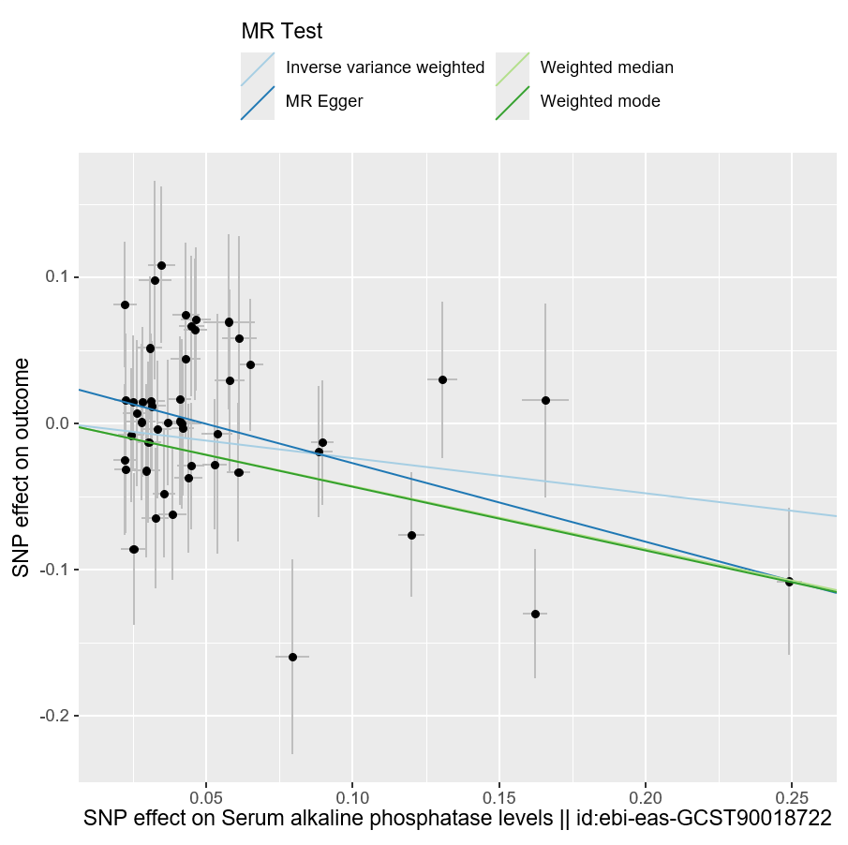
Supplementary Fig. 1. Scatter plot of SNPs associated with ALP and the risk of VTE. ALP, alkaline phosphatase; VTE, venous thromboembolism.
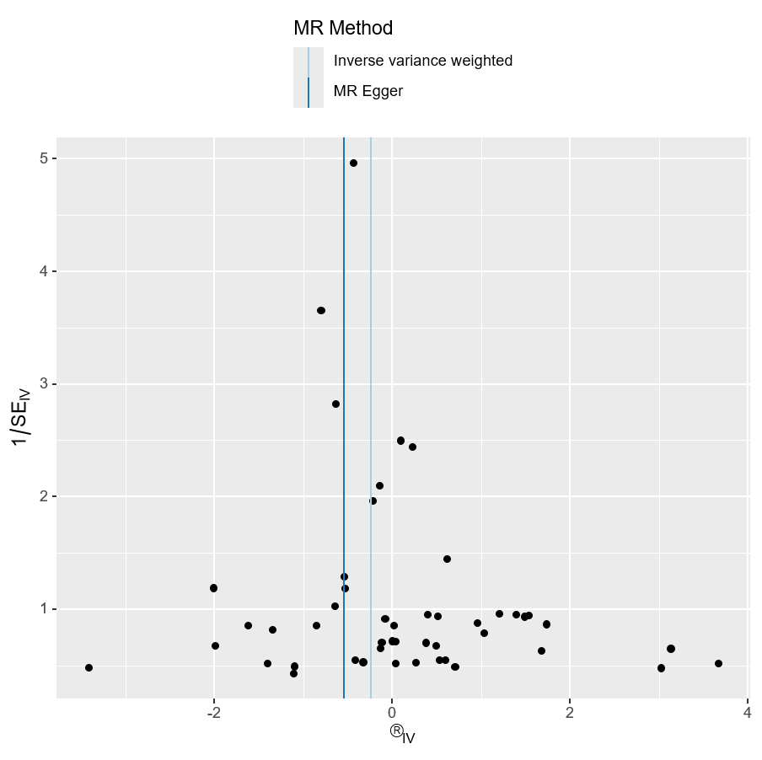
Supplementary Fig. 2. funnel plot of SNPs associated with ALP and the risk of VTE. ALP, alkaline phosphatase; VTE, venous thromboembolism; SE, standard error.
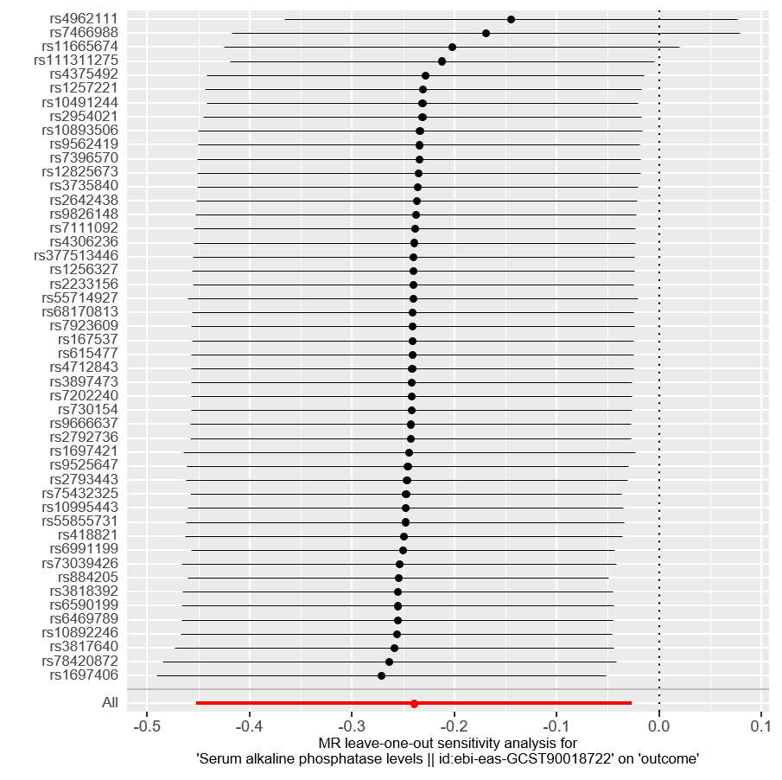
Supplementary Fig. 3. leave-one-out of SNPs associated with ALP and the risk of VTE. ALP, alkaline phosphatase; VTE, venous thromboembolism.

